KV WARANGAL
SUMMER VACATION HOLIDAY HOMEWORK MATHEMATICS
CLASS 8
SESSION (2023-24)

General Instructions:
- Do Holiday HW in Classwork copy (give heading SUMMER VACATION HW), no need to make separate copy.

  - Addition and subtraction of Rational number:

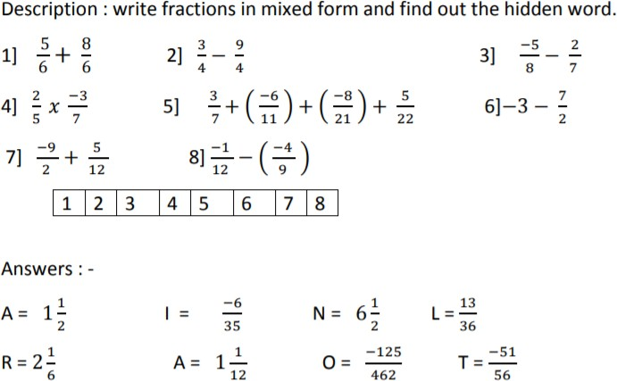

  - Find which of following is rational number:

1 11 , 0
, ¹³ ,0

5 54 35 0
  - Learn and write table from 2 to 25.
  - Learn and write square of numbers from 2 to 25. Ex. 2 × 2 = 4
  - Learn and write cube of numbers from 2 to 15. Ex. 2 × 2 × 2 = 8
  - Revise chapters = Rational numbers and Linear equation in one variable.
  - Solve following Worksheets given below.

WORKSHEET- 1 (RATIONAL NUMBERS)

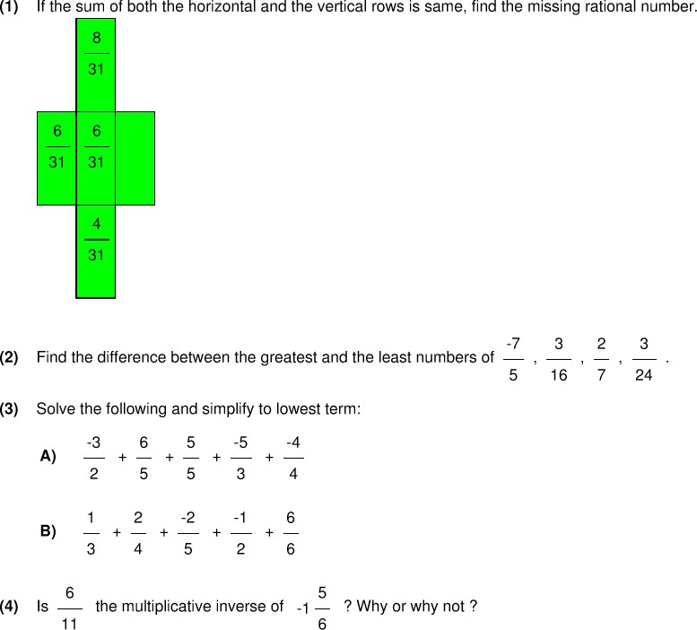

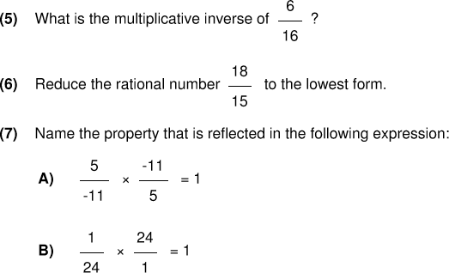

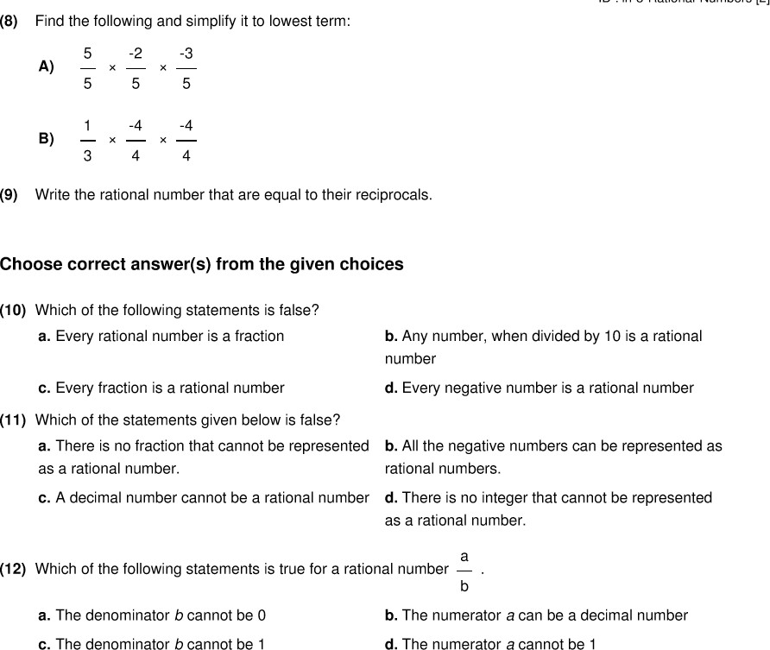

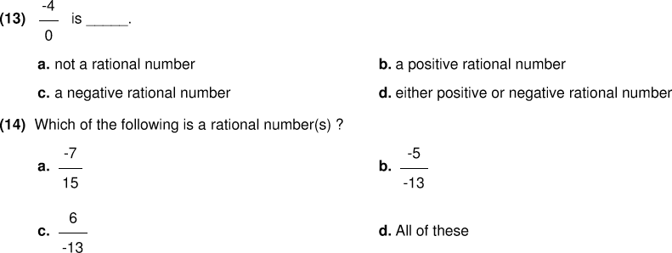

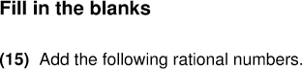

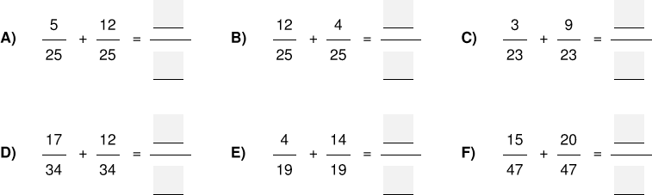

WORKSHEET- 2 (LINEAR EQUATION IN ONE VARIABLE)
